Video Analytics

[Spring 2017]

Assignment -1

**---------------------------------------------------**

**Gaurav Fogla (gmf160030)**

**----------------------------------------------------------------**

Report:

1. The path of the input Image is take through command line and is read into the program using the imread() function.

Next was to brighten the image by 50.

1. To brighten the input image, I have increased each pixel value by 50 and the brightened image looks like:

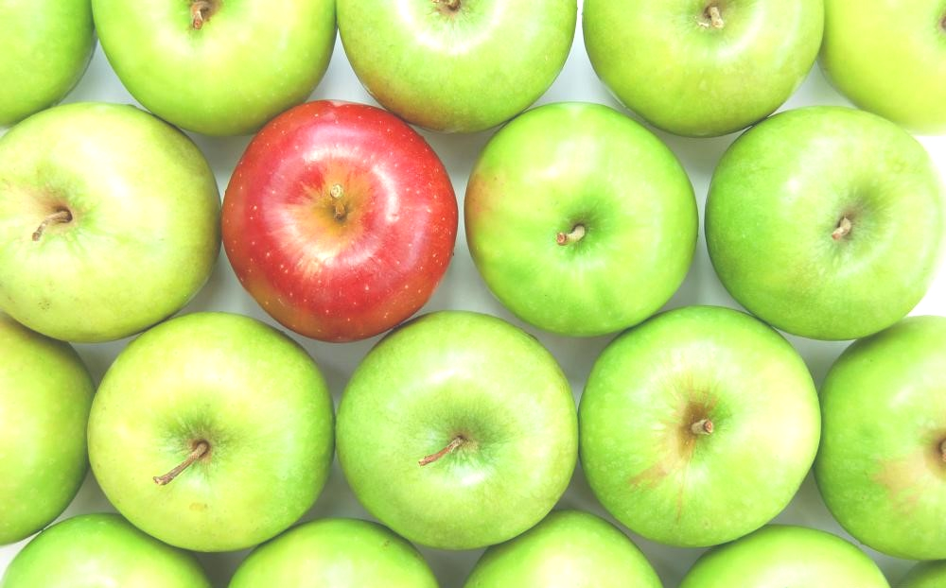

We had to convert the images from RGB to HSV domain.

1. For conversion I have used the following mathematical formula :

*R*' = *R*/255

*G*' = *G*/255

*B*' = *B*/255

*Cmax* = max(*R*', *G*', *B*')

*Cmin* = min(*R*', *G*', *B*')

Δ = *Cmax* – *Cmin*

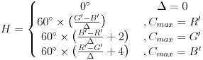

if (H < 0)

H = H + 360;

H = H/2;

http://www.rapidtables.com/convert/color/rgb-to-hsv/sat-calc.gif

*V* = *Cmax*

Thus HSV image of the:

Original Image looks like: Brightened Image looks like:

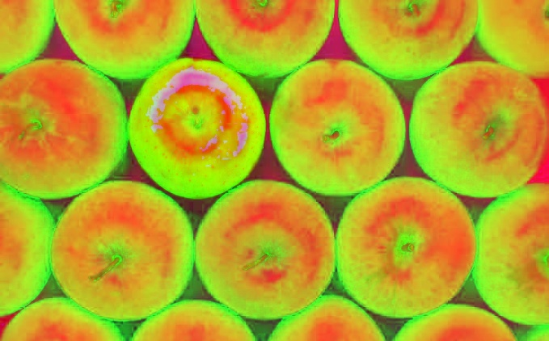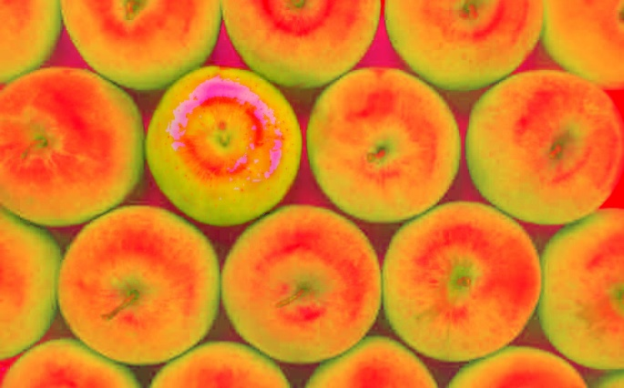

For Objection Detection, I have done in both the color domains (HSV & RGB)

1. HSV:

* I used the following thresholds:

Hue (H) between 0-12 OR 170-180

AND Saturation (S) greater than 70

AND Value (V) greater than 50.

RGB

* I used the following thresholds:

Red (R) greater than 140

AND Green (G) less than 120

If the above conditions are true then only those pixels are turned on where as the rest are turned off.

To remove the noise and secularize the detected region I filtered the image through the Median filter.

The resultant images look like:

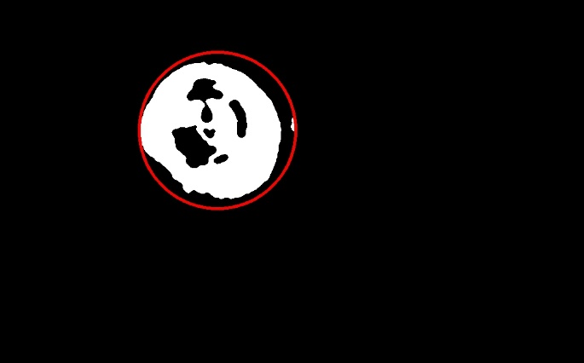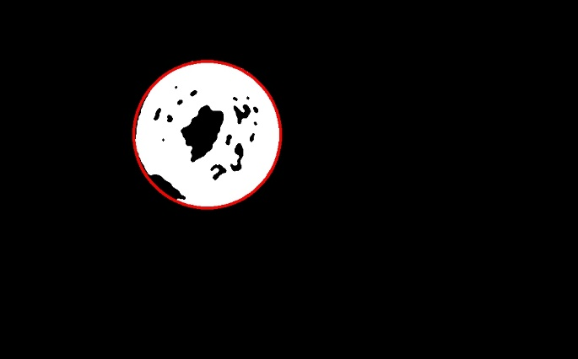HSV Domain: RGB Domain:

To draw the circle around the detected region, I used the Cirlce() function to which I passed the values of the center and radius by calculation the maximum width of the region both in the X and Y direction.

Then selecting the maximum/2 among the two widths as the radius and (CenterOfWidthX, CenterOfWidthY) as the center.

Lastly, I interchanged the colors of the apples i.e. the red one turned green and vice a versa.

I did this in both the HSV and the RGB Domain.

1. HSV:

In this I put a threshold value on the Hue (H) so as to detect the red and the green apples.

Once the apples were detected, I manipulated those values so that they fall in their respective category.

Like:

If Hue (H) is between 0-20, 45 is added to it. (Red to Green)

If Hue (H) is more than 160, it’s divide by 4. (Red to Green)

If Hue (H) is between 30-80, it’s made 5% of itself. (Green to Red)

RGB:

In this I switched the red and the green components of the pixel.

The output images are:

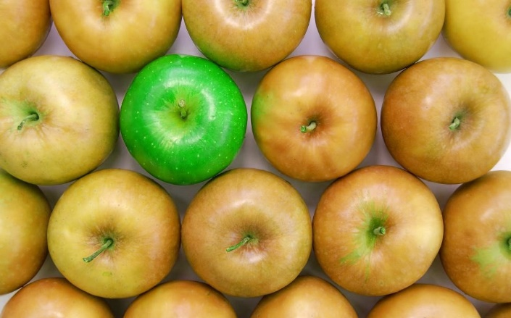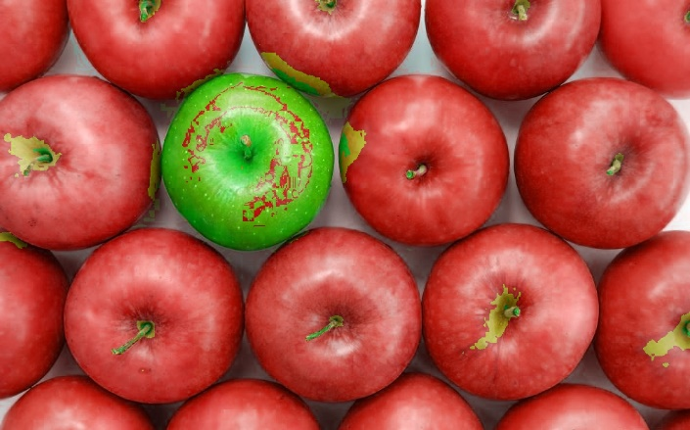HSV: RGB: